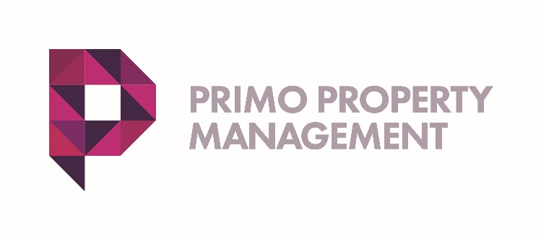
COMPLAINTS
Primo is committed to providing a good residential experience. However, if a student tenant is unhappy or has a complaint, the below is the procedure to follow.

As a firm accredited by ANUK National Codes, PRIMO PROPERTY MANAGEMENT aims to provide the highest standards of service. However, sometimes things go wrong – if that’s the case, then we definitely want to know about it.

If you believe you have grounds for a complaint, please write in the first instance to Ruby Jones (Associated Director, Primo) ruby@primopropertymanagement.co.uk

It is important to put your complaint in writing so that your issue gets resolved as soon as possible, and also we have a timescale we can work from.

Primo like to resolve things at an early stage and quickly, so that you can enjoy your stay with us. Once your email is received, it will be acknowledged by email and you will receive a phone call from Ruby Jones or another member of the management team, within 48 hours (or sooner). Hopefully, your issue will be resolved at this point.

However, should we need to investigate the detail of your complaint, then you will be advised of this, and a response will be sent to you within 14 days, outlining our findings and, where appropriate, any actions we propose to take to ensure your issues are resolved, you are happy, and can achieve your academic endeavours.

The ANUK National Code standards form the basis of all of our actions. Please take a look at National Code of Standards for Larger Developments here:
http://www.nationalcode.org/Upload/File/NationalCode_Private.pdf

If you are not happy with the outcome of Primo’s investigation, you can submit a Formal Complaint to the National Code Administrator, 155-157 Woodhouse Lane, Leeds. LS2 3ED / Telephone : 0113 243 0169

PLEASE BE ASSURED PRIMO WILL DO EVERYTHING IT CAN TO ENSURE YOUR ISSUE IS RESOLVED AT AN EARLY STAGE

